

Vocational Training Authority of Sri Lanka
LAN Report
LAN Project 2025
Submitted by:
JL/25/DICTL5/1/0006
P.H. Manoj Chathuranga
Submitted to:

(Supervisor’s signature)
………………………………
Mr.U.G.P.K. Nishantha
Date of Submission
03/11/2025

Introduction
Cisco Packet Tracer is a versatile network simulation software developed by Cisco Systems, enabling users to design, configure, and troubleshoot various network topologies in a virtual environment. This report documents five simulated network topologies created using Cisco Packet Tracer, focusing on key networking concepts from basic connectivity to intermediate configurations. The following topologies are explored in detail:
- Basic Two-Computer Connectivity: This topology establishes a simple peer-to-peer connection between two PCs, either through a direct crossover cable or via a switch. IP addresses are configured manually on each device, and end-to-end communication is verified using ping commands.
- VLAN Configuration: Virtual Local Area Networks (VLANs) are implemented to divide a single physical network into multiple logical broadcast domains. This lab demonstrates VLAN creation on switches, port assignment to specific VLANs, trunking between switches, and inter-VLAN routing using a router (router-on-a-stick) or a Layer 3 switch. VLANs enhance network security by isolating traffic, reduce broadcast domains, and improve overall manageability and performance.
- DHCP Configuration: A Dynamic Host Configuration Protocol (DHCP) server is set up on a router or dedicated server device to automatically assign IP addresses, subnet masks, default gateways, and DNS information to client devices. The configuration includes creating DHCP pools, excluding reserved IP ranges, and verifying assignments using commands like show Ip dhcp binding on the server and ipconfig on clients. This topology highlights the efficiency of automatic IP management in larger networks.
- Web Server Configuration: A web server is configured on a PC or server device in Packet Tracer, where a simple HTML page is hosted and HTTP/HTTPS services are enabled. Clients from the same or different networks access the server via a web browser, demonstrating client-server architecture, application-layer protocols (ports 80 and 443), and basic web service functionality.
- Static Router Configuration: Multiple routers are connected across different networks, with static routes manually configured to enable inter-network communication. This includes setting up specific static routes and default gateways, followed by verification using show ip route, ping, and traceroute commands. The lab emphasizes the simplicity of static routing for small networks, along with its limitations in scalability compared to dynamic routing protocols.

Methodologies for diagrams
Diagram 01 – Two Basic Computers Connect and Check the Connectivity This diagram demonstrates simple LAN connectivity between two PCs.
5.1 Device Topology & Cabling
- Devices: 2 x Personal Computers (PC0, PC1) and 1 x Cisco Catalyst 2960 Switch.
- Cabling: Both PCs are connected to the switch access ports using Copper Straight-Through cables. Since they are in the same network subnet, no routing device is required.
5.2 IP Configuration Summary
End devices are statically configured within the same IP subnet as follows:
- PC0 IP Address: 192.168.10.3 | Subnet Mask: 255.255.255.0
- PC1 IP Address: 192.168.10.5 | Subnet Mask: 255.255.255.0
- (Note: Default Gateway is not required as there is no router in this topology).
5.3 Verification
- Open the Command Prompt on PC0.
- Run the command: ping 192.168.10.5 in PC-01
- Result: The ping is successful with a 0% packet loss, confirming direct Layer 2 connectivity between the two end devices through the switch.

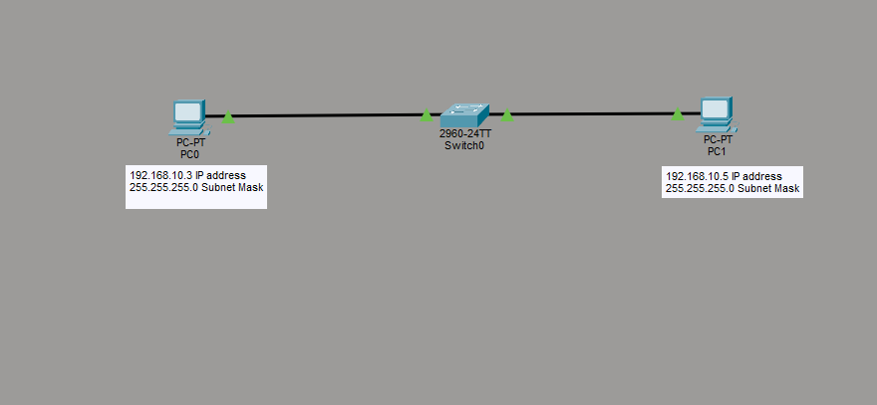

Diagram 02 - VLAN Configuration
Diagram 02 - VLAN Configuration This shows network segmentation using VLANs with inter-VLAN routing.
Configuration and Implementation Steps
Device Topology & Cabling
- Switches to PCs: Connected via Copper Straight-Through cables to access ports.
- Switch to Switch: Connected via Copper Cross-Over cable (Fa0/5 to Fa0/5) configured as a Trunk link.
- Switch to Router: Connected via Copper Straight-Through cable (Fa0/6 to Fa0/0) configured as a Trunk link for Router-on-a-Stick.
- Switch 0 Configuration
Switch0> enable
- Switch0# configure terminal

- ! Create VLANs
- Switch0(config)# vlan 10
- Switch0(config-vlan)# name Marketing
- Switch0(config-vlan)# vlan 20
- Switch0(config-vlan)# name Sales
- Switch0(config-vlan)# exit

- ! Assign Access Ports
- Switch0(config)# interface range fa0/1 - 2
- Switch0(config-if-range)# switchport mode access
- Switch0(config-if-range)# switchport access vlan 10

- Switch0(config)# interface range fa0/3 - 4
- Switch0(config-if-range)# switchport mode access
- Switch0(config-if-range)# switchport access vlan 20
- Switch0(config-if-range)# exit

- ! Configure Trunk Ports
- Switch0(config)# interface range fa0/5 - 6
- Switch0(config-if-range)# switchport mode trunk
- Switch0(config-if-range) # end

5.3 Switch 1 Configuration
Switch1> enable
Switch1# configure terminal
! Create VLANs
Switch1(config)# vlan 10
Switch1(config-vlan)# name Marketing
Switch1(config-vlan)# vlan 20
Switch1(config-vlan)# name Sales
Switch1(config-vlan)# exit
! Assign Access Ports
Switch1(config)# interface range fa0/1 - 2
Switch1(config-if-range)# switchport mode access
Switch1(config-if-range)# switchport access vlan 10
Switch1(config)# interface range fa0/3 - 4
Switch1(config-if-range)# switchport mode access
Switch1(config-if-range)# switchport access vlan 20
Switch1(config-if-range)# exit
! Configure Trunk Port
Switch1(config)# interface fa0/5
Switch1(config-if)# switchport mode trunk
Switch1(config-if)# end
5.4 Router Configuration (Inter-VLAN Routing)
Router> enable
Router# configure terminal

! Activate Physical Interface
Router(config)# interface fa0/0
Router(config-if)# no shutdown
! Configure Sub-interface for VLAN 10
Router(config)# interface fa0/0.10
Router(config-subif)# encapsulation dot1Q 10
Router(config-subif)# ip address 192.168.10.1 255.255.255.0
! Configure Sub-interface for VLAN 20
Router(config)# interface fa0/0.20
Router(config-subif)# encapsulation dot1Q 20
Router(config-subif)# ip address 192.168.20.1 255.255.255.0
Router(config-subif)# end
5.5 IP Configuration Summary
- VLAN 10 Subnet: 192.168.10.0/24 | Gateway: 192.168.10.1
- VLAN 20 Subnet: 192.168.20.0/24 | Gateway: 192.168.20.1
5.6 Verification
- Run show vlan brief on switches to verify port mapping.
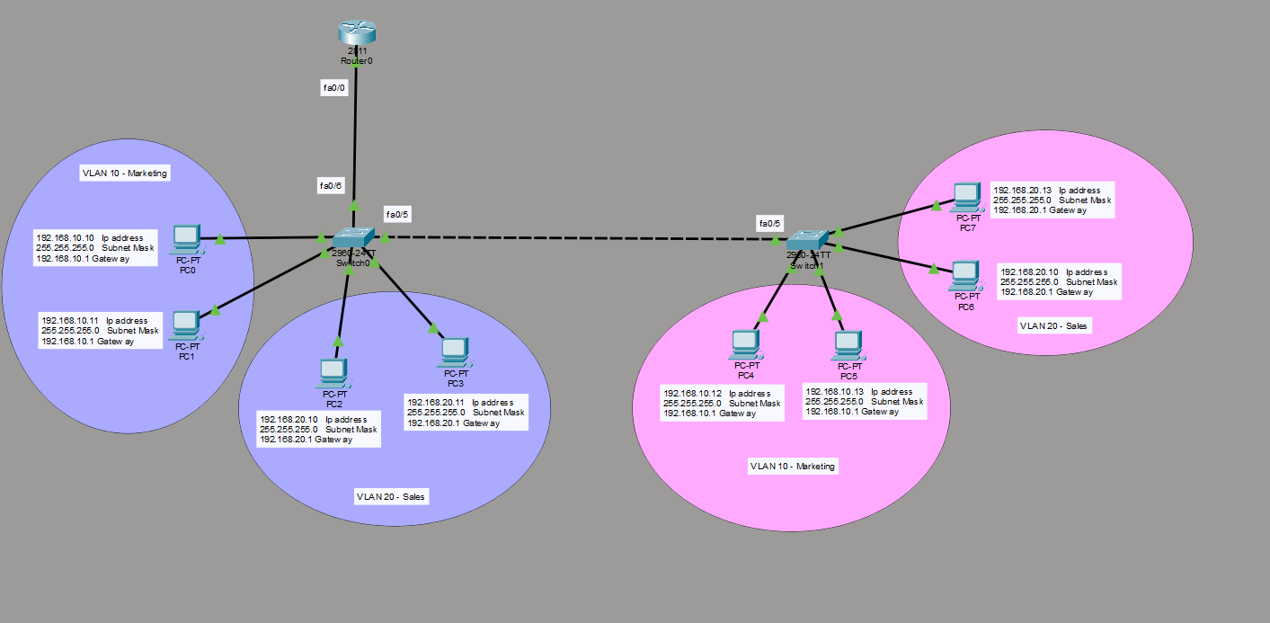
- Perform ping commands between different VLANs to verify Inter-VLAN routing success.
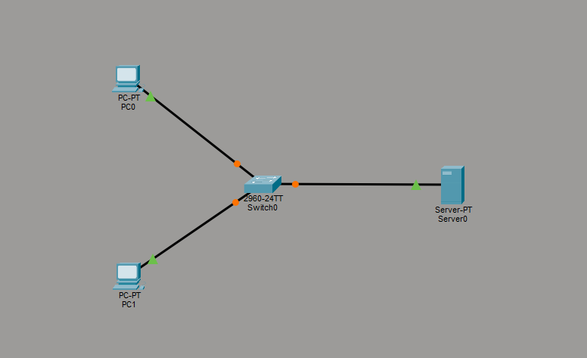
Diagram 3: DHCP Configuration

Introduction
The objective of this configuration is to dynamically assign IP addresses to client computers (PC0 and PC1) from a centralized server (Server0) using DHCP (Dynamic Host Configuration Protocol) within the network range 192.168.1.0/24.
Step 01: Assigning a Static IP Address to the Server
Before configuring the DHCP service, the server itself must have a fixed (Static) IP address.
- Click on Server0 and navigate to the Desktop tab.
- Click on IP Configuration.
- Select the Static radio button and enter the following details:
  - IP Address: 192.168.1.10
  - Subnet Mask: 255.255.255.0
  - Default Gateway: 192.168.1.1
Step 02: Configuring the DHCP Service on the Server
- While inside the Server0 window, navigate to the Services tab.
- Select DHCP from the services list on the left panel.
- Turn On the DHCP Service by selecting the radio button.
- Select the default pool named serverPool and configure the pool parameters as follows:
  - Default Gateway: 192.168.1.1
  - DNS Server: 0.0.0.0 (Leave as default)
  - Start IP Address: 192.168.1.20 (IP allocation will begin from this address).
  - Subnet Mask: 255.255.255.0
  - Maximum number of Users: 50
- Click the Save button to update the pool settings.
Step 03: Configuring Clients to Receive Dynamic IP Addresses
- Click on PC0, go to the Desktop tab, and select IP Configuration.
- Change the IP assignment selection from Static to DHCP.
- Wait for a few seconds. The status will display "DHCP request successful", and the PC will automatically receive the IP address 192.168.1.20.
- Repeat the same process for PC1. It will automatically receive the next available IP address, 192.168.1.21.
Step 04: Verification and Testing
To verify the connectivity between the clients and the server:
- Open PC0, go to the Desktop tab, and click on the Command Prompt.
- Execute the ping command to test connectivity with the DHCP server:
DOS ping 192.168.1.1
- A successful response (0% loss) confirms that the DHCP configuration is working perfectly and network communication is established.

Diagram 04: Web Server Configuration

Step-by-Step Guide for Web Server (HTTP) Configuration in Cisco Packet Tracer
Introduction
The objective of this configuration is to host a basic web page on Server0 using the HTTP service and allow client computers (PC0 and PC1) to access the website using the server's static IP address (192.168.1.10).
Step 01: Assigning a Static IP Address to the Server
A web server must have a fixed (Static) IP address so that clients always know where to find it.
- Click on Server0 and navigate to the Desktop tab.
- Click on IP Configuration.
- Select the Static radio button and enter the following parameters:
  - IP Address: 192.168.1.10 (This acts as the permanent address of your website)
  - Subnet Mask: 255.255.255.0
  - Default Gateway: 192.168.1.1
Step 02: Enabling the HTTP Service
Next, you need to turn on the web hosting service inside the server.
- Inside the Server0 window, switch to the Services tab.
- From the left-hand menu, click on HTTP (the first option).
- Ensure that both HTTP and HTTPS options are set to On (They are usually enabled by default).

Step 03: Customizing the Web Page (Editing index.html)
To display a personalized message when clients visit the server, we can edit the default homepage file.
- In the HTTP services window, look at the file list at the bottom and locate the index.html file.
- Click on the edit link next to index.html.
- A basic HTML code editor will open. Find the line that says: <h1>Welcome to Cisco Packet Tracer</h1>
- Change it to your own custom text. For example: <h1>Welcome to Manoj's Web Server</h1>
- Click the Save button at the top of the editor. When prompted to overwrite the file, click Yes.
Step 04: Verifying and Testing Web Access from Client PCs
Now, we will test if the client PCs can successfully retrieve the web page from the server.
- Click on PC0 (or PC1), navigate to the Desktop tab, and open the Web Browser application.
- In the URL bar at the top, type the Static IP address of the web server:
192.168.1.10
- Click the Go button or press Enter.
- The customized HTML web page hosted on Server0 will successfully load on the browser screen.

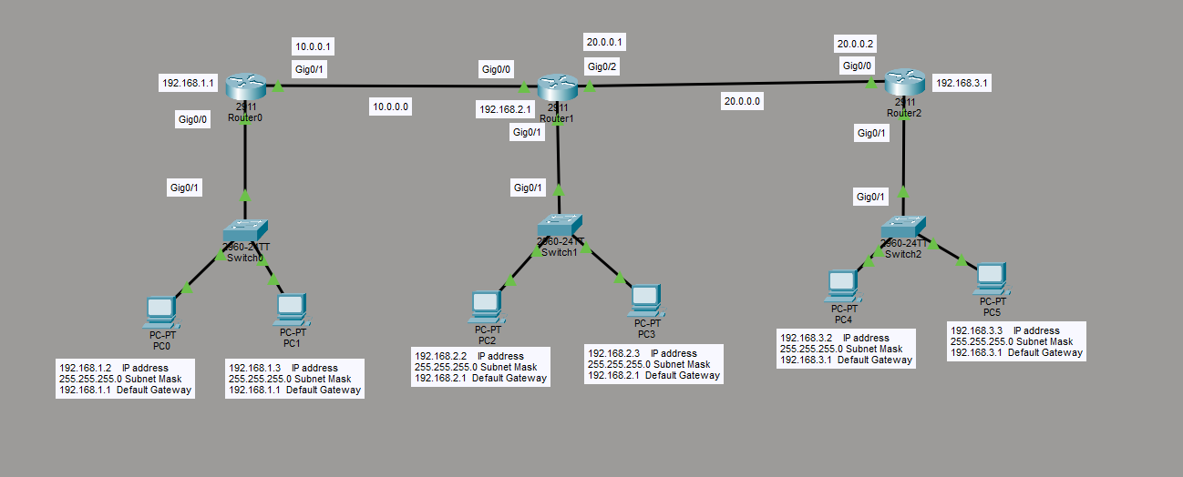
Diagram 4: Static Router Configuration

Static Routing Configuration Report Across Three Subnets
Part 01: Network Topology & Hardware Components
The network design consists of three Local Area Networks (LANs) interconnected via three Cisco 2911 Integrated Services Routers to enable end-to-end communication using Static Routing.
- Routers: 3 x Cisco 2911 Routers (Named as Router0, Router1, and Router2)
- Switches: 3 x Cisco Catalyst 2960-24TT Switches
- End Devices: 6 x PCs (2 PCs per local network)
- Cabling Infrastructure:
  - Copper Straight-Through Cables: Employed for all PC-to-Switch and Switch-to-Router (LAN gateway) connections.
  - Copper Straight-Through Cables (with Auto-MDIX): Employed for Router-to-Router (WAN link) connections.

Part 02: Interface and IP Addressing Plan
Device Name | Interface | Connected To | IP Address | Subnet Mask | Default Gateway
Router0 (Left) | GigabitEthernet0/0  GigabitEthernet0/1 | Switch0 (LAN 1)  Router1 (WAN 1) | 192.168.1.1  10.0.0.1 | 255.255.255.0  255.0.0.0
Router1 (Middle) | GigabitEthernet0/1  GigabitEthernet0/0  GigabitEthernet0/2 | Switch1 (LAN 2)  Router0 (WAN 1)  Router2 (WAN 2) | 192.168.2.1  10.0.0.2  20.0.0.1 | 255.255.255.0  255.0.0.0  255.0.0.0 | N/A  N/A  N/A
Router2 (Right) | GigabitEthernet0/1  GigabitEthernet0/0 | Switch2 (LAN 3)  Router1 (WAN 2) | 192.168.3.1  20.0.0.2 | 255.255.255.0  255.0.0.0
PC0 | FastEthernet0 | Switch 0 | 192.168.1.2 | 255.255.255.0 | 192.168.1.1
PC1 | FastEthernet0 | Switch 0 | 192.168.1.3 | 255.255.255.0 | 192.168.1.1
PC2 | FastEthernet0 | Switch 1 | 192.168.2.2 | 255.255.255.0 | 192.168.2.1
PC3 | FastEthernet0 | Switch 1 | 192.168.2.3 | 255.255.255.0 | 192.168.2.1
PC4 | FastEthernet0 | Switch 2 | 192.168.3.2 | 255.255.255.0 | 192.168.3.1
PC5 | FastEthernet0 | Switch 2 | 192.168.3.3 | 255.255.255.0 | 192.168.3.1

Part 03: Step-by-Step CLI Configuration Commands
Step 01: Interface Configuration (Assigning IPs & Activating Ports)
Access the Command Line Interface (CLI) tab of each router in Cisco Packet Tracer and execute the following commands to initialize the interfaces:
1. Router0 (Left Router):
Router> enable
Router# configure terminal
Router(config)# interface GigabitEthernet0/0
Router(config-if)# ip address 192.168.1.1 255.255.255.0
Router(config-if)# no shutdown
Router(config-if)# exit

Router(config)# interface GigabitEthernet0/1
Router(config-if)# ip address 10.0.0.1 255.0.0.0
Router(config-if)# no shutdown
Router(config-if)# exit
2. Router1 (Middle Router):
(Note: A HWIC-1GE-SFP hardware module must be installed prior to powering on the router to enable the third interface GigabitEthernet0/2).
Router> enable
Router# configure terminal
Router(config)# interface GigabitEthernet0/1
Router(config-if)# ip address 192.168.2.1 255.255.255.0
Router(config-if)# no shutdown
Router(config-if)# exit

Router(config)# interface GigabitEthernet0/0
Router(config-if)# ip address 10.0.0.2 255.0.0.0
Router(config-if)# no shutdown
Router(config-if)# exit

Router(config)# interface GigabitEthernet0/2
Router(config-if)# ip address 20.0.0.1 255.0.0.0
Router(config-if)# no shutdown
Router(config-if)# exit
3. Router2 (Right Router):
Router> enable
Router# configure terminal
Router(config)# interface GigabitEthernet0/1
Router(config-if)# ip address 192.168.3.1 255.255.255.0
Router(config-if)# no shutdown
Router(config-if)# exit
Router(config)# interface GigabitEthernet0/0
Router(config-if)# ip address 20.0.0.2 255.0.0.0
Router(config-if)# no shutdown
Router(config-if)# exit

Step 02: Static Routing Table Configuration
To allow successful packet forwarding to non-directly connected remote subnets, input the static routes mapping the destination networks to their respective next-hop IP addresses:
On Router0 (Left Router):
Router(config)# ip route 192.168.2.0 255.255.255.0 10.0.0.2
Router(config)# ip route 192.168.3.0 255.255.255.0 10.0.0.2
Router(config)# ip route 20.0.0.0 255.0.0.0 10.0.0.2
On Router1 (Middle Router):
Router(config)# ip route 192.168.1.0 255.255.255.0 10.0.0.1
Router(config)# ip route 192.168.3.0 255.255.255.0 20.0.0.2
On Router2 (Right Router):
Router(config)# ip route 192.168.1.0 255.255.255.0 20.0.0.1
Router(config)# ip route 192.168.2.0 255.255.255.0 20.0.0.1
Router(config)# ip route 10.0.0.0 255.0.0.0 20.0.0.1
Part 04: Static Routing Summary Table
Source Router | Destination Network | Subnet Mask | Next-Hop IP (Gateway) | Exit Interface
Router0 | 192.168.2.0 (LAN 2)  192.168.3.0 (LAN 3)  20.0.0.0 (WAN 2) | 255.255.255.0  255.255.255.0  255.0.0.0 | 10.0.0.2  10.0.0.2  10.0.0.2 | GigabitEthernet0/1  GigabitEthernet0/1  GigabitEthernet0/1
Router1 | 192.168.1.0 (LAN 1)  192.168.3.0 (LAN 3) | 255.255.255.0  255.255.255.0 | 10.0.0.1  20.0.0.2 | GigabitEthernet0/0  GigabitEthernet0/2
Router2 | 192.168.1.0 (LAN 1)  192.168.2.0 (LAN 2)  10.0.0.0 (WAN 1) | 255.255.255.0  255.255.255.0  255.0.0.0 | 20.0.0.1  20.0.0.1  20.0.0.1 | GigabitEthernet0/0  GigabitEthernet0/0  GigabitEthernet0/0

Part 05: Connectivity Verification & Testing
- Navigate to PC0 -> Desktop -> Command Prompt.
- Run the ping test to verify the route mapping to PC5 located on the furthest subnet:
DOS
ping 192.168.3.3
- Observation: The initial ICMP packet results in a Request Timed Out. This delay is an expected behavioral phenomenon caused by the ARP (Address Resolution Protocol) broadcast broadcasted across the networks to map target MAC addresses.
- Subsequent packet transmissions yield a 100% success rate with steady ICMP echo replies, validating a fully operational network topology.

